[](http://www.eco-schools.org.uk/)***Canon Burrows ECO School Committee***[](http://www.eco-schools.org.uk/)

***School year 2019 / 2020***

|  |  |
| --- | --- |
| **Liam Greenwood** | Year 6 – Miss Clayton |
| **Leah McGregor** | Year 6 – Miss Clayton |
| **Eva Jenner** | Year 6 – Miss Howard |
| **Ayaan Naveed** | Year 6 – Miss Howard |
| **Gracie Schofield** | Year 5 –Miss Gaskell |
| **Freya Dooley** | Year 5 – Mrs Foulds |
| **Lucy Hodgson** | Year 4 – Mr Horne |
| **Maddison Jones** | Year 4 – Mr Richardson |
| **Fox Pickersgill** | Year 3 – Miss Large |
| **James Bennett** | Year 3 – Miss Matthews |
| **Livia Kiln** | Year 2 – Ms Drake |
| **Jaxson Boardman** | Year 2 – Miss Muzyka |
| **Harriet Lowe** | Year 1 – Miss Clewlow |
| **Stevie Pilling** | Year 1 – Ms Adamson |
| **Mr Clark** | ESD/ECO leader |
| **Ms Sutton** | Teacher |
| **Mr Vance** | Caretaker |
|  |  |

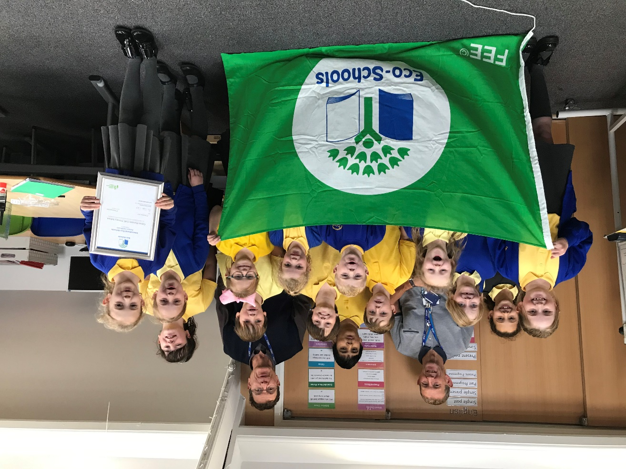

## [Eco-Schools](http://www.eco-schools.org.uk/)NA01441_[Eco-Schools](http://www.eco-schools.org.uk/)

## Eco committee meeting; Wednesday 9th October 2019

## The Committee met in the ICT Suite @ 2.30 pm

* **Apologies from; Miss Arnold, Miss Sutton**
* **Mr Clark welcomed everyone**
* **We started with a team photo as time was short today**
* The Reps all introduced themselves beautifully and like last year this year’s Eco team gave wonderful reasons for wanting to be their class Eco reps……. Maddison; Watering and caring for plants, Lucy; Recycling to make the world a better place, Liam; Making the world safer, Freya; Trying to stop people driving so much, Harriet; Make the world better, Gracie; Stopping pollution. James; Helping to save animals, Stevie; Picking up litter, Fox; Looking after our environment, Lydia; Helping people, Jaxson; Planting plants, Eva; Making sure she does her part to help save the world, Ayaan; Doing everything he can to save the world.
* Mr Clark explained about how the meetings work, the role of being an Eco rep, how to use the Eco books every class has and the monitors that classes should have. Every new rep was given a copy of “Your role as an Eco Rep”
* EXTRA ITEM; Together we reviewed and amended the school Eco code. Please can everyone replace the old one in classrooms
* Ideas for using the money raised at the Green Fair;

*Donate ½ to charities and use ½ for Eco projects in school was agreed*

*Charities suggested; WWF and cancer research*

* **Reps reports*;***

**We had very little time for Reps ideas unfortunately. Please can Eco reps bring them again to the next meeting BUT:**

**Freya: did** suggested bins in classes for recycling plastic

We finished by everyone being thanked for a lovely first meeting of the school year.

**Please check notice board for dates of next meeting.**